2019.04.8

**Reward Module/Coupon Module**

1. **Objective**
2. Customer to get reward points after every transaction
3. Customer can redeem loyalty points for free service charge/discounted exchange rate/gift items
4. Customer should be able to use Coupon while sending txn – to get certain discounts in service charge or exchange rate.
5. **Modification required**
6. **GME Core**
   1. Loyalty point setup page



* 1. Display reward points earned in “Approved Customer”
  2. Display Available Coupons under “Approved Customer”

1. **Mobile App**
   1. Display reward point earned as pop up after txn is complete

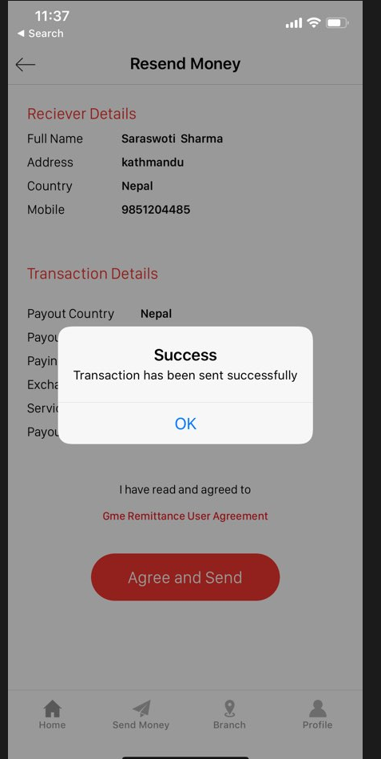

OK

Your transaction is successful.

You earned 200 Points

* 1. Design a page to redeem the reward point

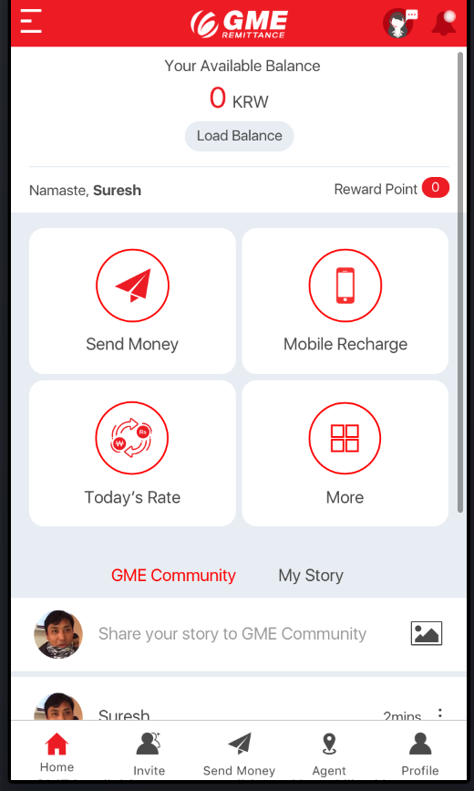

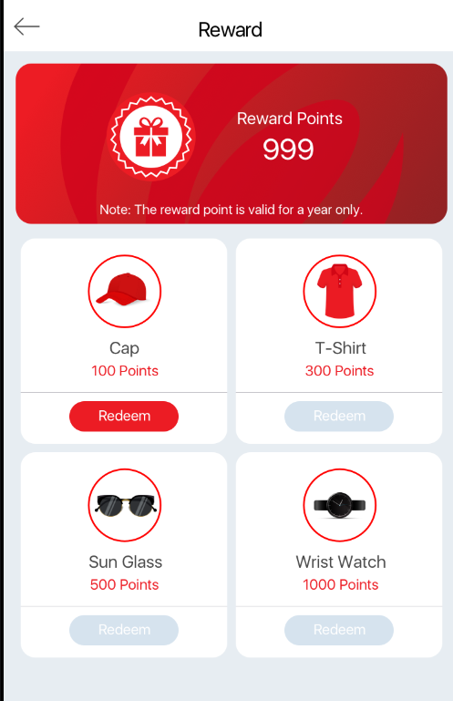

* 1. Put one field in drop down menu of available coupons to individual customer while sending money

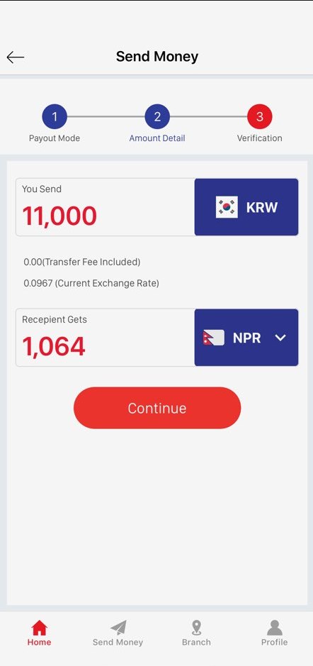

1.Free service Charge

Use Discount Coupon